
ecotone tours and travels
162 Khro apartment
Lower Bayavu
Kohima : Nagaland
Contact- +91-9856119175

Day 1- Dimapur - Kohima
Meet a representative at Dimapur Airport, the commercial hub of Nagaland, get surface transfer to Kohima.(Capital of Nagaland).
Overnight in Kohima
DAY 2 – KOHIMA
Kohima is the capital city of Nagaland, a state in Northeast India renowned for its diverse indigenous tribes and vibrant culture. The city, originally called Kewhira, is nestled in the Naga Hills at an altitude of 1444m above sea level. It gained historical significance during World War II as the site of the Battle of Kohima, which played a crucial role in halting the Japanese advance into British India.
- Kohima War Cemetery: A poignant tribute to the soldiers who sacrificed their lives during the Battle of Kohima in World War II.
- Kisama Heritage Village: Showcasing the diverse cultural heritage of the Naga tribes, especially during the annual Hornbill Festival.
- Nagaland State Museum: A treasure trove of artifacts, traditional costumes, and tribal art, offering insights into Naga culture.
- Mary Help of Christians Cathedral: Known for its unique architecture and the 16 feet high carved wood crucifix, one of the largest in Asia.
- Local Bazaar: Explore local markets for unique handicrafts, textiles, and traditional Naga products.
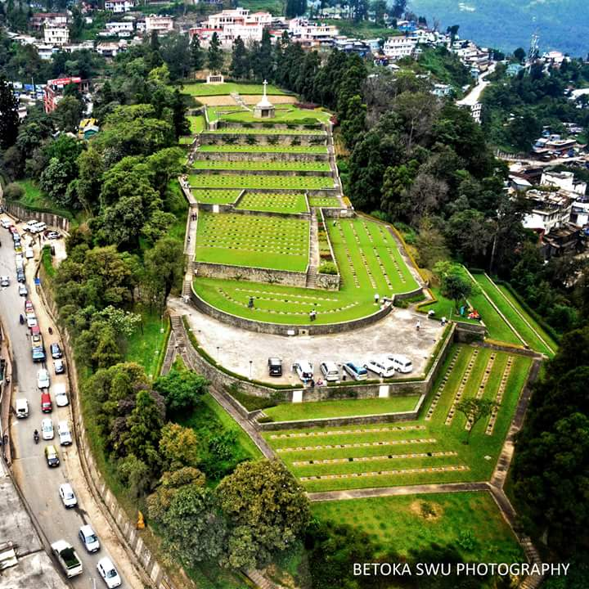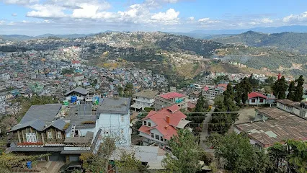

DAY 3 – KOHIMA - KHONOMA
Khonoma is a picturesque village in Nagaland, India, renowned for its commitment to environmental conservation and its rich Angami Naga cultural heritage. It has earned the distinction of being India's first “Green village” in India due to its villagers dedication to sustainable practice and wildlife preservation.
- History and Culture: Khonoma boasts a 700-year-old history and is home to the Angami Naga tribe, known for their bravery and vibrant traditions.
- Battle of Khonoma: The Angami tribe famously resisted British colonial rule for decades, culminating in the "Battle of Khonoma" in the late 19th century.
- Sustainable practices: Khonoma is a model for sustainable living, with widespread organic farming, terraced cultivation, and a strict ban on hunting and logging within the sanctuary.
- Community involvement: The success of Khonoma's conservation and development initiatives is rooted in its strong social and political structures, including the Village Council and youth associations, which actively promote community participation.
- Eco-tourism: Khonoma attracts tourists interested in experiencing a unique blend of nature and Naga culture, including homestays, traditional cuisine, guided nature walks, and opportunities to learn about sustainable farming methods.
. Morungs: The traditional morung, or boys' dormitory, serves as a center for education and cultural preservation, teaching young men about warfare, sports, craftsmanship, and social responsibilities.
Overnight stay in Kohima.

.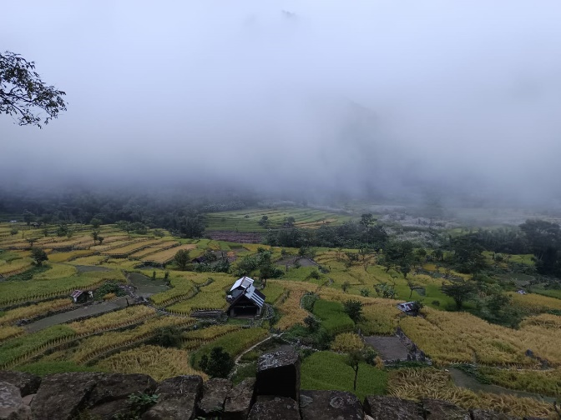
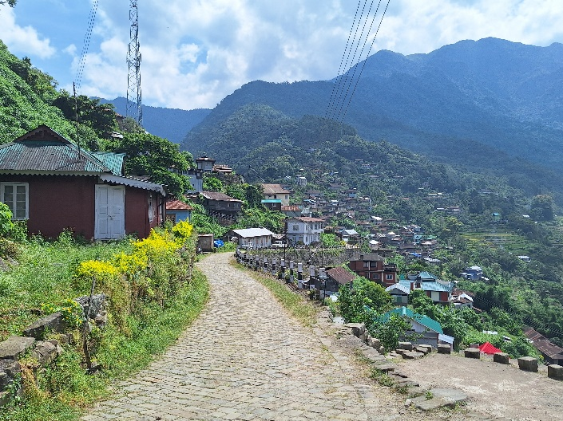
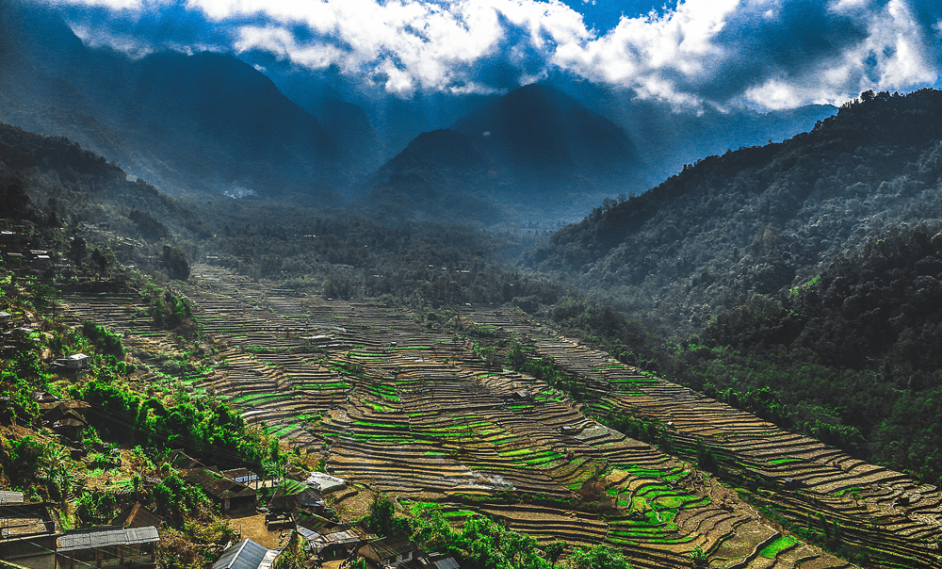

Day 4 – KOHIMA – DIMAPUR
After breakfast we journey down to Dimapur to connect the flight for onward journey

Tour End

