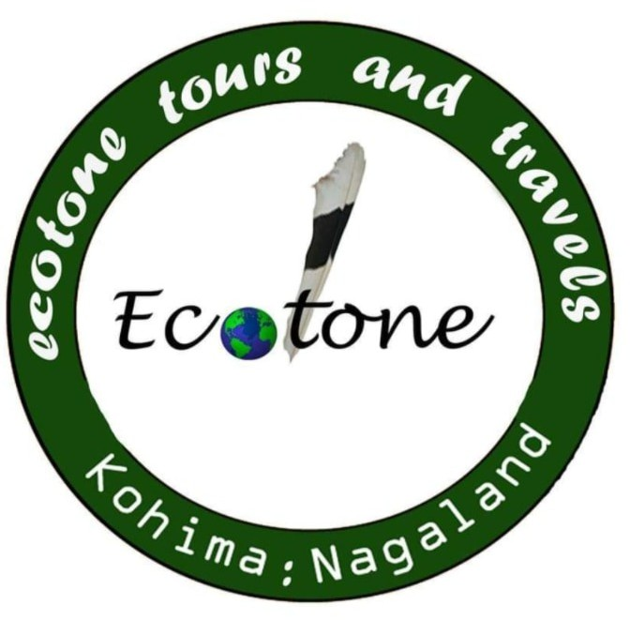
ecotone tours and travels
162 Khro apartment
Lower Bayavu
Kohima : Nagaland
Contact- +91-9856119175

Day 1 – 1 December 2026 (Arrival & Opening Day)

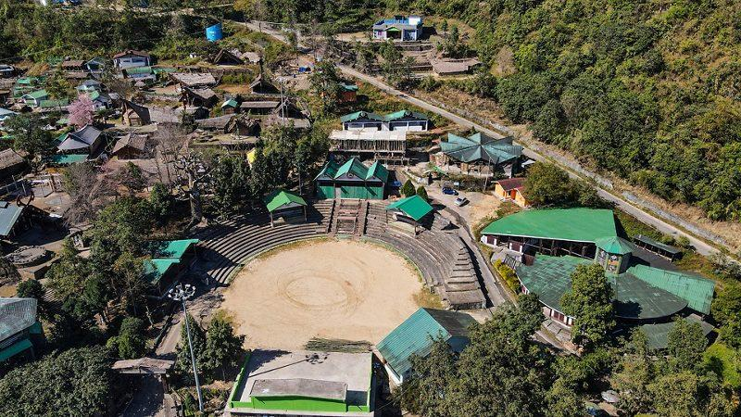
Morning
- Arrive at Dimapur Airport/Railway Station.
- Drive to Kohima (3–4 hours depending on traffic).
Afternoon
- Check in at your accommodation in Kohima, Kigwema, or Phesama.
- Proceed to Kisama for the opening ceremony.
Evening
- Explore the tribal morungs.
- Sample traditional Naga cuisine.
- Attend opening cultural performances and music events.

Day 2 – 2 December (Full Festival Experience)
- Spend the entire day at Kisama.
- Watch performances from different Naga tribes.
- Visit handicraft and handloom stalls.
- Experience indigenous games and Naga wrestling.
- Attend evening concerts.
Photography tip: Morning light around the morungs is excellent for portraits and cultural photography.

Day 3 – 3 December (Festival + Kohima Heritage)
Morning
- Festival activities at Kisama.
Afternoon
- Visit:
  - Kohima War Cemetery
  - Nagaland State Museum
  - Kohima local market
Evening
- Return to Kisama for night events and food festival.

Day 4 – 4 December (Khonoma Excursion)
Take a half-day trip to:
- Khonoma Village, often called India's first green village.
Activities:
- Village walk.
- Learn about Angami culture.
- Explore terraced fields.
- Traditional lunch with local hosts.
Return to Kohima by evening and attend festival concerts.

Day 5 – 5 December (Dzükoü Valley Trek)
Option A (Recommended for active travelers)
- Early morning trek to Dzükoü Valley.
- Full-day hike.
- Return to Kohima in the evening.
Option B
- If you prefer a relaxed pace, spend another day at Hornbill Festival and explore lesser-visited morungs and workshops.

Day 6 – 6 December (Festival Finale for Your Trip & Departure)
- Enjoy cultural performances you may have missed.
- Depart for Dimapur Airport/Railway Station.

Suggested Base
- Phesama – closest to Dzükoü Valley and Kisama.
- Kigwema – convenient for festival access.
- Kohima – best for restaurants and evening activities.

Summary
1–2 Dec: Festival immersion
3 Dec: Festival + Kohima heritage
4 Dec: Khonoma village
5 Dec: Dzükoü Valley trek
6 Dec: Final festival day + departure

