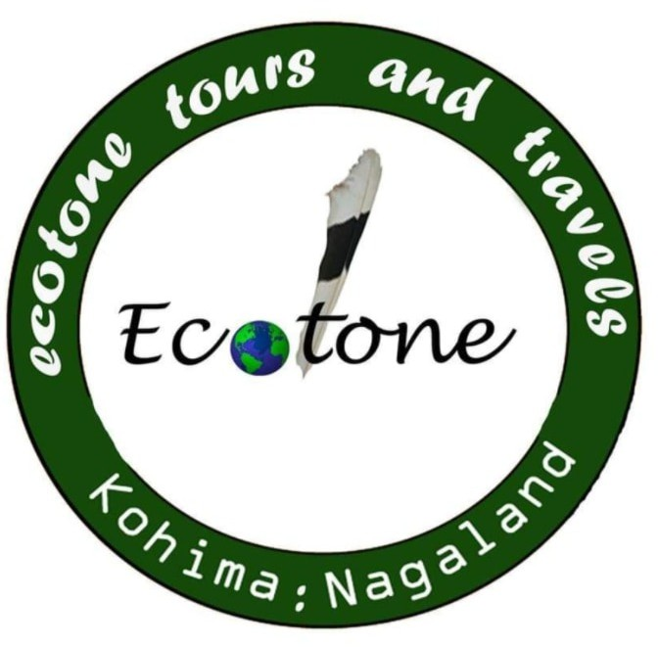
ecotone tours and travels
162 Khro apartment
Lower Bayavu
Kohima : Nagaland
Contact- +91-9856119175

Day1 (28 nov.) – Dimapur – Benreu
Meet a representative at Dimapur Airport, the commercial hub of Nagaland, get surface transfer to Benreu Village.
Benreu village is home to a vibrant and culturally rich community primarily composed of the Zeliang Naga tribe, specifically the Zeme Naga community. Benreu village, with its rich cultural heritage and diverse ecosystem, represents a unique blend of traditional knowledge and natural beauty. The local community's sustainable practices and growing conservation efforts play a crucial role in preserving this ecological gem. As eco-tourism and awareness continue to grow, Benreu stands as a model for integrating cultural preservation with environmental stewardship.
Overnight stay in Benreu Homestay.
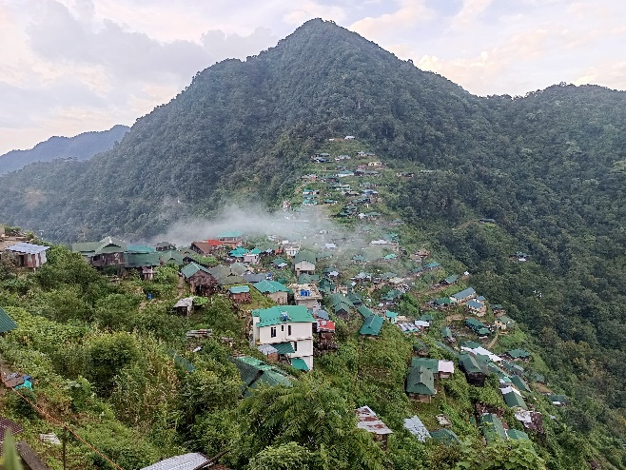
Day 2(29 nov) – Benreu- Dzuleke – Khonoma
After we proceed to Khonoma village the first Green village in India via Dzuleke villege.
Overnight stay at Khonoma(Homestay)

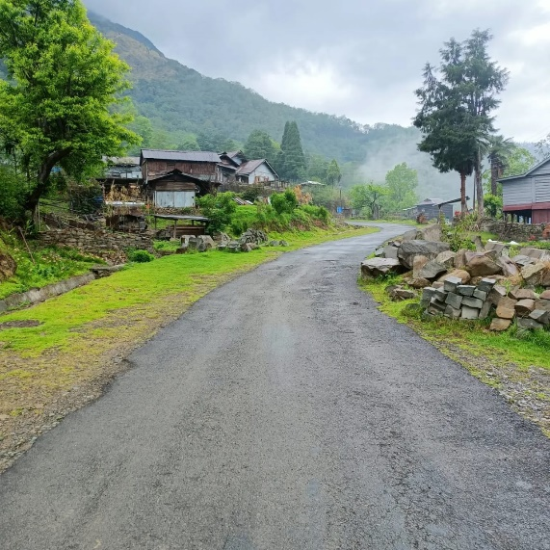

Day 3(30 nov) – Khonoma
Khonoma is a picturesque village in Nagaland, India, renowned for its commitment to environmental conservation and its rich Angami Naga cultural heritage. It has earned the distinction of being India's first “Green village” in India due to its villagers dedication to sustainable practice and wildlife preservation.
- History and Culture: Khonoma boasts a 700-year-old history and is home to the Angami Naga tribe, known for their bravery and vibrant traditions.
- Battle of Khonoma: The Angami tribe famously resisted British colonial rule for decades, culminating in the "Battle of Khonoma" in the late 19th century.
- Eco-tourism: Khonoma attracts tourists interested in experiencing a unique blend of nature and Naga culture, including homestays, traditional cuisine, guided nature walks, and opportunities to learn about sustainable farming methods.
Overnight stay at Khonoma(Homestay)
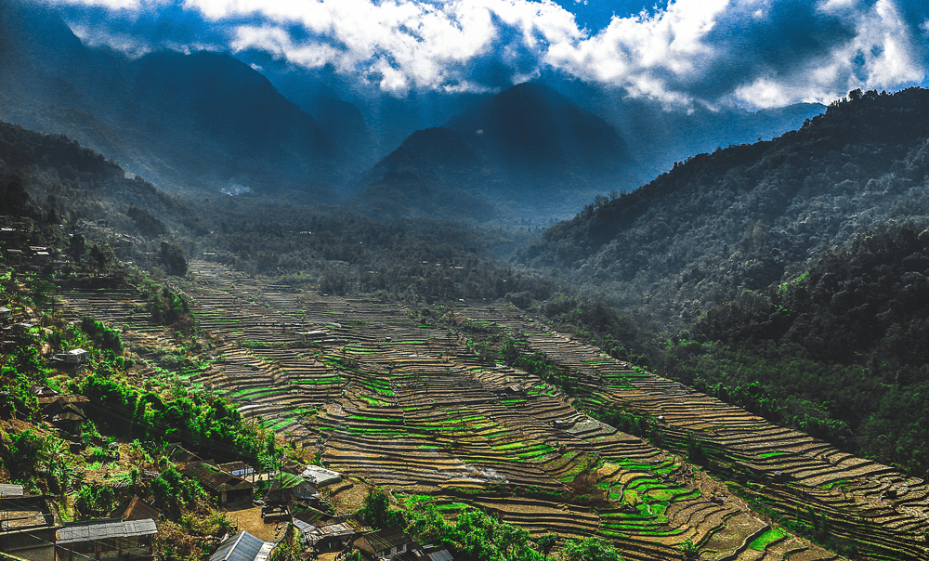
Day 4 (1st dec) – Hornbill Festival
The hornbill festival is a celebration held everyear from 1st December to 10 December in Nagaland, North East India. It is also called the “Festival of Festivals”. The hornbill festival provides a colorful mixture of dances, performance, art and crafts, parades, games and sports, food fairs and religious ceremonies. The aim of the festival is to revive and protect the rich culture of Nagaland and display its extravaganza and traditions.
Overnight stay at Khonoma/Kohima (Homestay)
Day 5(2nd dec) – Hornbill Festival
We shall spend the rest of our day in Hornbill festival filled with songs and dances, and people in full festive mood with colorful attires. We shall also see shop where you can pick up souvenirs to take home for your dear ones. We then shall have lunch at the festival where you can taste local food.
Overnight stay at Khonoma/Kohima (Homestay)

Day 6(3rd dec) – Hornbill Festival
After breakfast we shall explore Kohima War cemetery, State museum, Cathedral, Local Market etc . Later in the evening will joint Hornbill Festival.
Overnight stay at Khonoma/Kohima (Homestay)
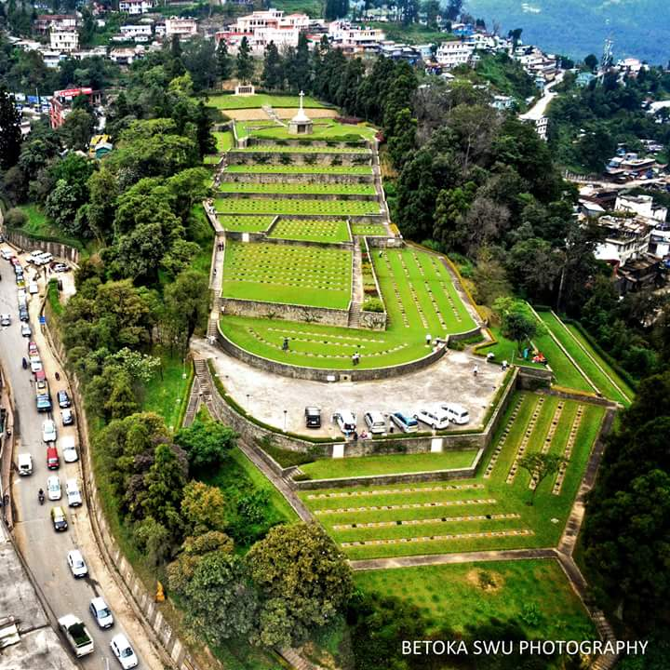
Day 7(4th dec) – Kigwema – Mima – Khezhakeno
- Drive to Khezhakeno village (legendary ancestral village of Nagas).
- Explore ancient stone monuments, Tso Tawo Lake, and local folklore.
- Cultural immersion with Chakhesang Nagas.
Overnight in Khezhakeno (homestay).
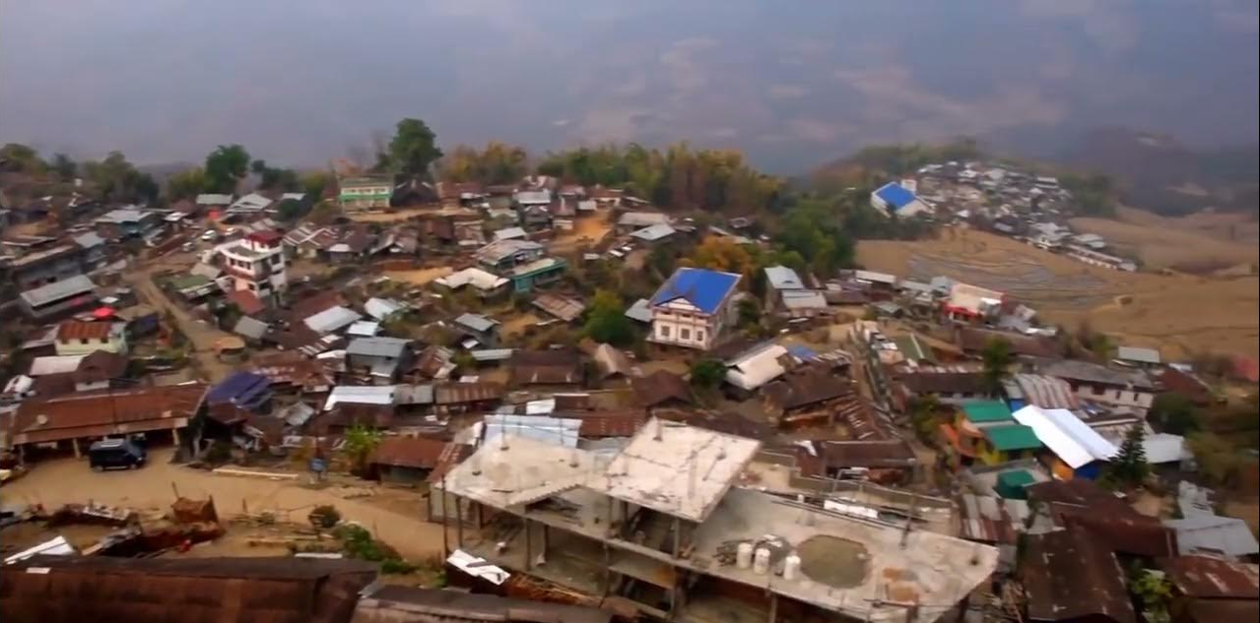

Day 8(5th dec) – Kapamodzu
Kapamüdzü is a mountain peak in the Zhavame village falls under Phek District of the Indian state of Nagaland.^{[1]} Standing at an elevation of 2,620 m (8,596 ft), it is the fourth-highest peak in Nagaland and also the highest table mountain in the state. Later in the evening drive to Pfutsero.
Overnight stay in Pfutsero(Homestay)

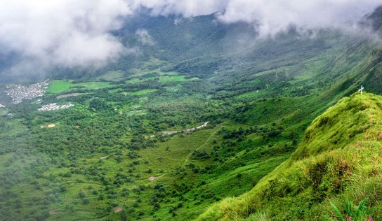

Day 9(6th dec) – Pfutsero(The Highest Inhabited Town In Nagaland)
Start the day with a morning hike to Glory Peak. It is an easy and short hike with awe inspiring views from the top.Post lunch drive back to Kohima. While on the way we shall visit Zapami village.
Overnight stay in Kohima.
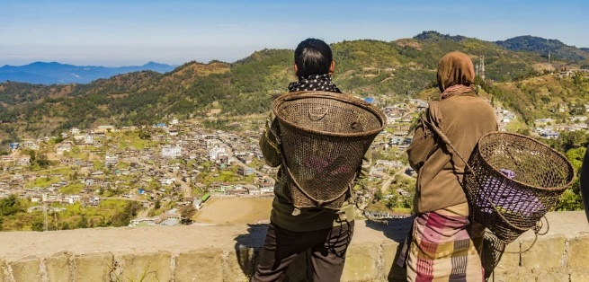

Day 10(7th dec) – Kohima – Mokokchung
We drive to Mokokchung District. Mokokchung is a land of Ao Naga tribe. Whle on the way we shall explore Tophema village, wokha town.
Overnight stay on Hotel/homestay
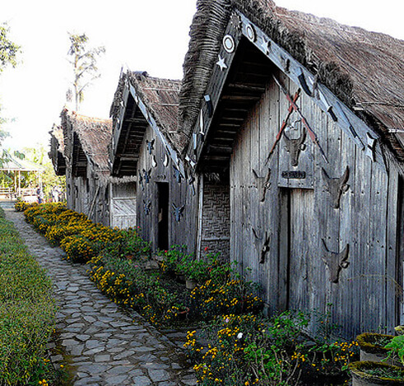
Day 11(8th dec) – Mokokchung - Mopongchuket
Mokokchung has a lot to offer to the visitors, from natural wonders, historical sites, cultural villages, and more.
Overnight stay in Mokokchung/mopongchuket homestay.
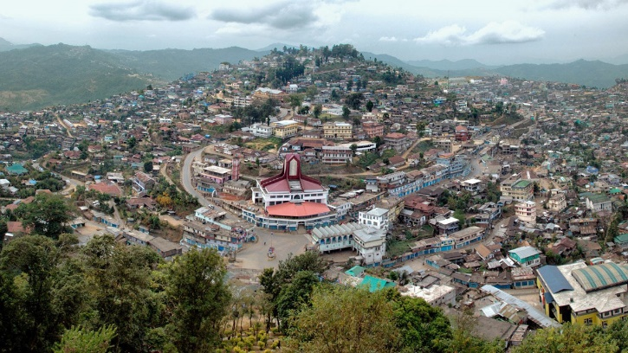
Day 12(9 dec) – Mopongchuket – Mon
After breakfast we shall drive to Mon (Land of Angh). The land of Konyak tribe.

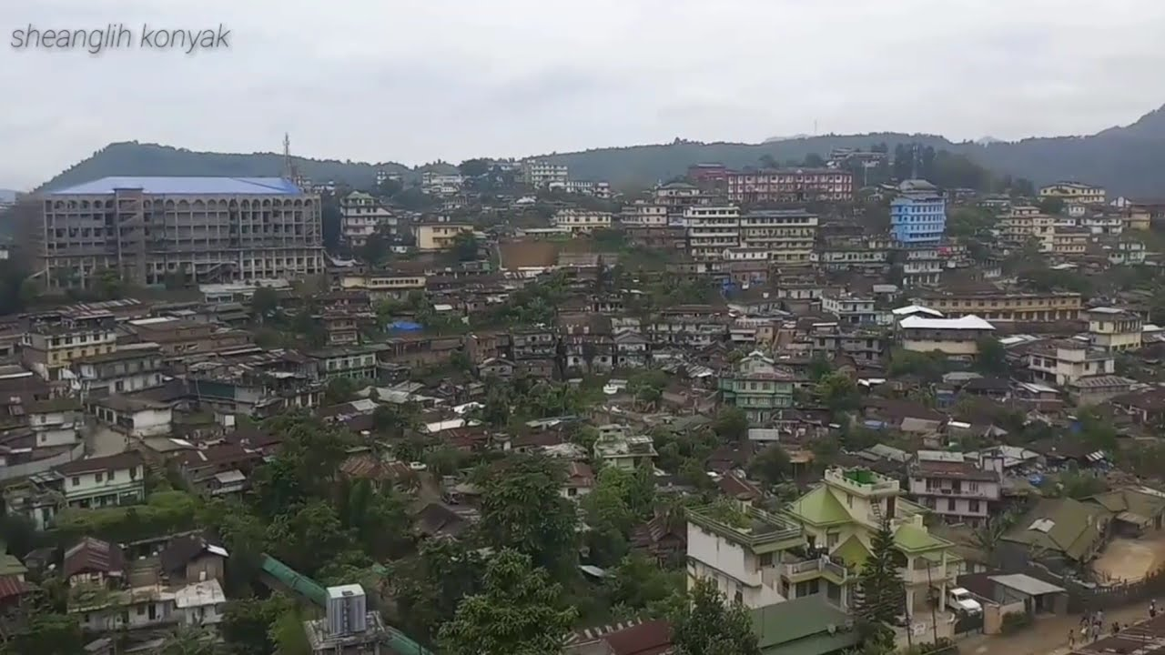
Day 13(10 dec) – Mon – Longwa
One of the largest villages of Mon district, this is a highly interesting place. The Angh’s house here lies half in India half in Myanmar. Even though the village lies in two countries, the entire village is ruled by the chief. The natural beauty is immense as a total of four rivers flow through the village, two in India and two in Myanmar.
Overnight stay in Longwa
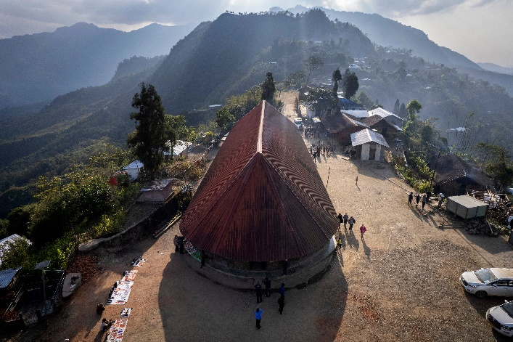

Day 14 – Longwa – Mon
After breakfast we shall drive back to Mon town. We shall also explore and get to knome more about the Konyak tribe.
Overnight stay in Mon.
Day 15 – Mon – Debrugarh
After breakfast we journey down to Debrugarh to connect the flight for onward journey

